**General guidelines to authors:**

**Extended Abstract:**

Extended abstracts should be written according to underlying structure for 2 pages including no more than 2 figures or tables and no more than 5 references of the structured abstract and in a form that is shorter than the full text and should contain a minimum of 1000 words. All Titles should be in Times New Roman, 12 font size and bold. Page margins are formed regarding the A4 page size and are 2.5 cm wide from the right, left, top and bottom. End of the lines should be aligned to the right and there should be no syllable segmentation.

As a guideline, we recommend that you structure your extended abstract as follows:

* Abstract and keywords
* Introduction
* Methodology
* Result
* Discussion
* Conclusion
* Acknowledgement and References

Your paper will be evaluated based on the following criteria:

1. The significance of your contribution to the research field.

2. The appropriateness of the methodology used.

3. The presentation and justification of your experimental results or theoretical analysis.

4. The quality and presentation of figures, tables, and relevant graphs.

5. The overall structure and quality of the paper.

**Extended Abstract Template is given below:**

**TEMPLATE AND INSTRUCTIONS FOR EXTENDED ABSTRACTS OF ICNAN’25 (TIMES NEW ROMAN, 14 FONT SIZE, BOLD, ALL CAPS, CENTERED)**

Author’s Name and Surname1, Author’s Name and Surname2* (10 font size)

*1Organization information of the author*

*2Organization information of the author*

*\*Corresponding author E-mail:* [*xyz@gmail.com*](mailto:xyz@gmail.com)

**ABSTRACT**

The Abstract which must be no more than 100 words long and contain no references should serve both as a general introduction to the topic and as a brief, non-technical summary of the main results and their implications. Abstract should be written with 12 font size, Times New Roman, single line spacing.

***Keywords:*** This section should contain maximum 5 words separated by commas.

1. **INTRODUCTION** (Times New Roman, 12 font size, bold, all caps)

The introduction section should (1) present the scope and objective of the paper and state the problem, (2) briefly review the pertinent literature, (3) describe the methods, and (4) provide an overview of the main results of the work. **(NO more than 100 words)**

**2. MATERIALS AND METHODOLOGY**

All materials and methods that have been used in the work must be stated clearly and subtitles should be used when necessary. The methodology can be described in sufficient detail or with sufficient references. The author shall explain the research question, describe the research framework, and the methods applied in detail. **(NO more than 100 words)**

**3. RESULTS**

Presentation of the result obtained. **(NO more than 300 words)**. If possible, use descriptive figures or tables rather than explain in text. All of the tables, images and figures should be centered and numbered consecutively. The table header should be placed at the top of the chart. Table, image and figure headers should be written with upper case initial letters, bold. The figures must be referenced in the text as Figure 1. References (if any) of the tables, figures and images should be presented just under the tables, figures and images in the form of author surname and publication date. A sample figure is as shown below

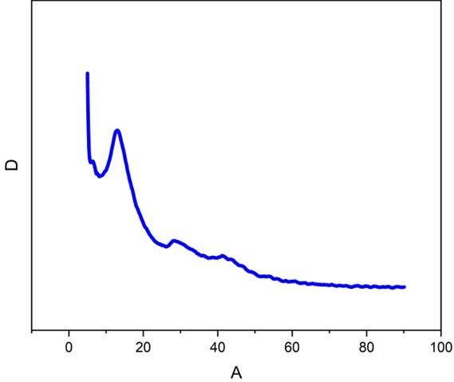

Figure 1. Heading

Table 1. Heading

|  |  |  |  |
| --- | --- | --- | --- |
| Sample No | 2θ | FWHM | d |
| A1 | 20.5 | 0.494 | 3.2408 |
| A2 | 24 | 0.567 | 2.713 |

*Reference: author surname and publication date*

**4. CONCLUSION**

Please conclude your work incorporating your most important finding as well as future works **(NO more than 100 words)**.

**ACKNOWLEDGEMENT**

Please acknowledge your research grant, organization, scholarship (where relevant)

**REFERENCES**

References should be listed in alphabetical order and presented in a commonly accepted format but in a consistent style. Use the following examples:

Reference to journal publications:

Syrrokostas, G., Siokou, A., Leftheriotis, G. & Yianoulis, P. Solar Energy Materials & Solar cells Degradation mechanisms of Pt counter electrodes for dye sensitized solar cells. Sol. Energy Mater. Sol. Cells 103, 119–127 (2012).

Reference to book:

Smith, F. J., & Jones, E. (1948). A scheme of qualitative organic analysis. London: Blackie.